MOVING iMAGE TECHNOLOGIES
BP1 (“Bullet Proof”) Automation
Description
The Moving iMage Technologies model BP1 is an automation interface to enable a projector IMB to control all the functions in a cinema without additional complicated electronics. The BP1 has no microprocessor or network capability. It’s dumb, simple, and “Bullet Proof.”

The I/O to the BP1 is by contact closure. The BP1 accepts commands from the projector IMB and turns them into dry contact relay outputs that go to terminal blocks.

Features
- PCB is a drop-in replacement for a JNIOR
- Simple digital logic only, no microprocessor, no software
- Interconnection with projector is by regular modular or CAT cables
- Dedicated fire alarm input (may be configured for pulsed or maintained modes)
- LEDs show the status of all relay outputs

Part numbers:
A000392-001 JNIOR replacement kit with the BP1 circuit board and signal cables
A000393-001 Complete BP1 rack-mounted system, 19” wide by 1 RU
B000630-001 BP1 Printed Circuit Board assembly only
Figure 1 is a line diagram showing the signal paths through the BP1 board.
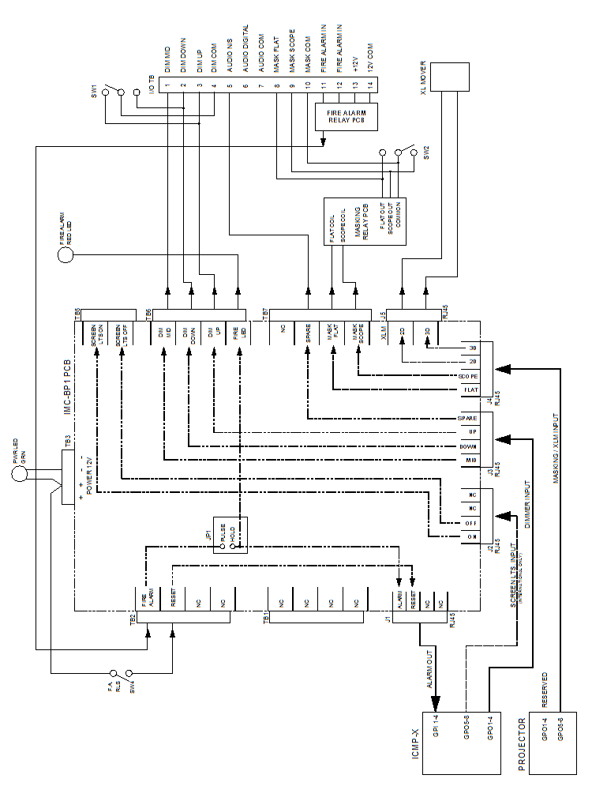
Figure 1

